DEPARTMENT OF COMMERCE & MANAGEMENT

SL.NO | DETAILS OF THE EVENT
1. | Title of The Event | Internship Regulation and Guidelines
2 | Day and Date | 08/04/2026
3 | Venue | TOCSAM- Auditorium
4 | Organizing Secretary/ Co-Coordinators | Mrs. Ayesha Siddiqa
5 | Resource Person With all details | Dr. Mohammed Farooq Pasha
6 | Participants | Final Year BBA, BCOM & BCA
6 | No of Student and staff present | 100 + Students and 9 Faculty Members

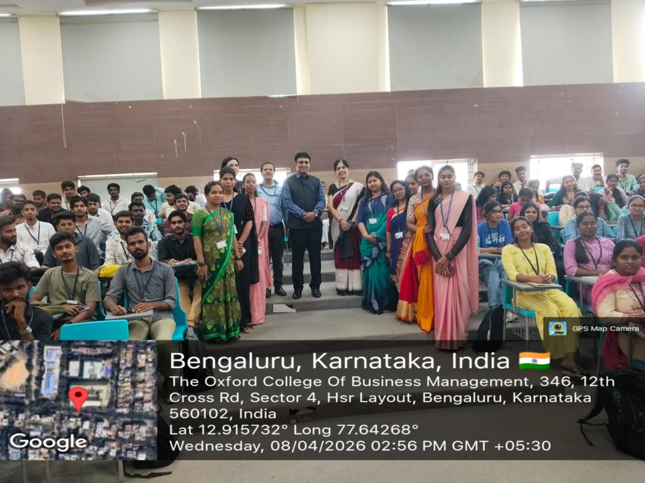 | 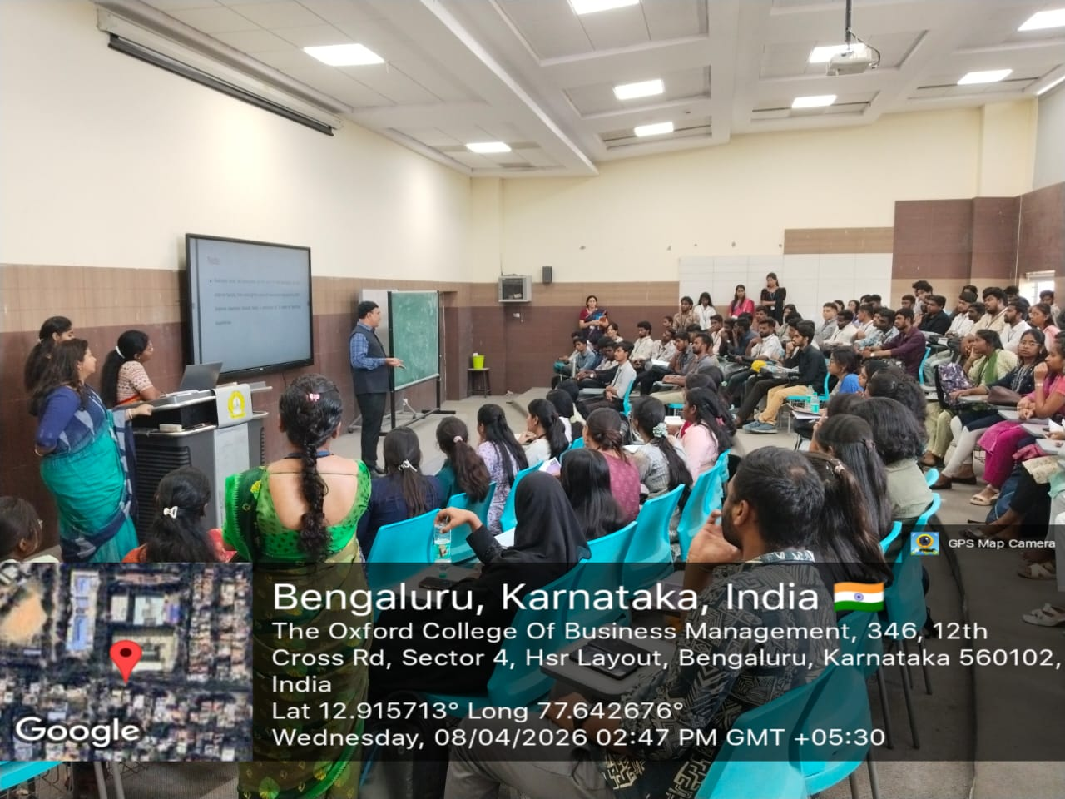

The Department of Commerce and Management successfully conducted a Technical Talk on "Internship Regulation and Guidelines" on April 8, 2026. Guest speaker Dr. Mohammed Farooq Pasha addressed final-year BBA and B.COM students in Seminar Hall 407 (TOCSACM-HSR Campus). The session provided students with a comprehensive roadmap for their professional training, ensuring they meet all institutional and industry requirements.

Coordinator HOD Vice-Principal Principal

